|  |
| --- |
|  |
| Capstone Project Document |

**BOOKAHOLIC SOCIAL NETWORK**

Report #2 – Data Design

|  |  |  |
| --- | --- | --- |
| **Bookaholic Social Network** | | |
| **Group Members** | Thái Thị Cẩm Vân | SE03409 |
| Vũ Hải Đăng | SE03380 |
| Phạm Thị Huyền | SE03416 |
| Nguyễn Thị Hải Yến | SE03171 |
| Chu Minh Hải | SE03143 |
| **Supervisor** | Mr. Nguyễn Văn Sang | |
| **Project code** | BSN | |

**- Hanoi, 10/2016 –**

# SIGNATURE PAGE

AUTHOR: Thái Thị Cẩm Vân --/--/2016

Developer

REVIEWERS: --- --/--/2016

APPROVAL: Nguyễn Văn Sang --/--/--16

Supervisor

Record of change

*A - Added M - Modified D – Deleted

|  |  |  |  |  |  |
| --- | --- | --- | --- | --- | --- |
| Effective Date | Changed Item | A,M,D | Change Description | Reason for Change | Rev. Number |
| --/--/2016 | Create Data Design | A | Create Data Design | First version | 1.0 |
|  |  |  |  |  |  |
|  |  |  |  |  |  |

Table Contents

SIGNATURE PAGE 1

1 INTRODUCTION 3

1.1 Purpose 3

1.2 Acronyms and Definitions 3

1.3 References 3

1.4 Overview 3

2 Database 4

2.1 Entity Relationship Diagram 4

2.1.1 Entity description 5

2.1.2 Relationship 5

2.2 Table Diagram 6

2.2.1 Users Collection 7

2.2.2 Posts Collection 8

2.2.3 Books Collection 9

2.2.4 Authors Collection 10

2.2.5 Publishers Collection 10

2.2.6 Reports Collection 11

2.2.7 Category Collection 11

2.2.8 Groups Collection 11

2.2.9 Slides Collection 12

2.2.10 BookStatistic Collection 12

# INTRODUCTION

## Purpose

This document describes structure of database and file structure of system including internal file structure as well as interface file structure.

## Acronyms and Definitions

|  |  |
| --- | --- |
| **Acronym & Abbreviation** | **Definition** |
| BSN | Bookaholic Social Network |
| FU | FPT University |
| Q&A | Question and Answer |

Table ‑: Acronyms and Definitions

## References

|  |  |
| --- | --- |
| **Document** | **Title** |
| Class Design Document | BSN_Class Design_v1.0 |
| Architecture Design | BSN_Architecture Design_v1.0 |
| Software Requirement Specification | BSN_Software Requirement Specification_v1.0 |

Table ‑: References

## Overview

This document describes relationship between entities and properties of each entity.

# Database

## Entity Relationship Diagram

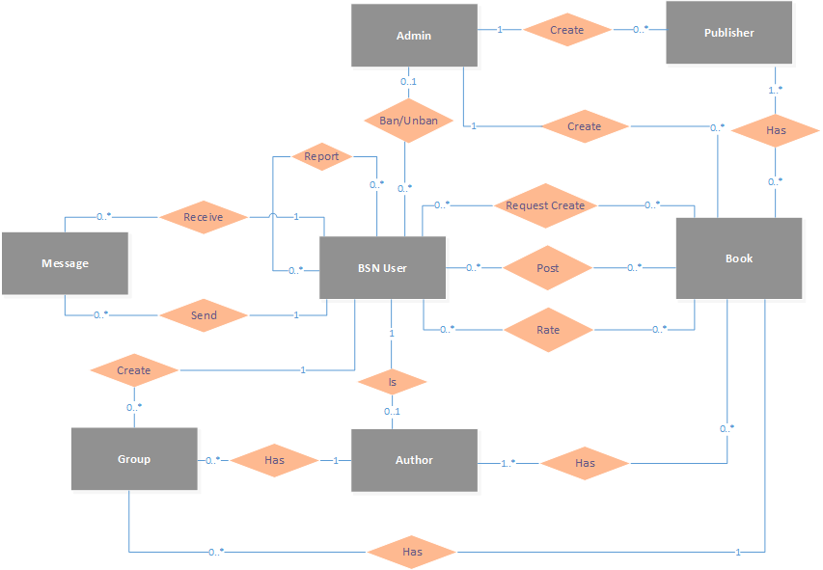

**Figure 2‑1:** Entity Relationship Diagram

### Entity description

|  |  |  |
| --- | --- | --- |
| **No** | **Entity** | **Description** |
|  | BSN User | User is all people who using BSN feature |
|  | Author | Kind of special User that has book on their own in BSN |
|  | Admin | User that manager BSN system |
|  | Book | A book which user can view or interact with it |
|  | Publisher | A Publisher which produce book |
|  | Group | A Group which user created and joined |
|  | Message | A Message which user send or receive to talk together |

**Table 2-3:** Entity description

### Relationship

|  |  |  |  |  |
| --- | --- | --- | --- | --- |
| **No** | **Relation** | **From** | **To** | **Description** |
|  | Create | Admin | Publisher | An admin create publishers and a publisher is created by an admin |
|  | Create | Admin | Book | An admin creates a books and a book is created by an admin |
|  | Has | Book | Publisher | Each book has its publishers |
|  | Ban/Unban | Admin | BSN User | Admin bans/unbans BSN users form system |
|  | RequestCreate | BSN User | Book | A BSN user request to create new books |
|  | Post | BSN User | Book | BSN users posts about books |
|  | Rate | BSN User | Book | BSN user rate for a books |
|  | Receive | BSN User | Message | BSN user receive messages from other BSN users |
|  | Send | BSN User | Message | BSN user send messages to other BSN Users |
|  | Create | BSN User | Group | BSN user create groups |
|  | Has | Group | Author | Each group is about an author or a book |
|  | Has | Group | Book | Each group is about an author or a book |
|  | Has | Author | Book | Author has books |

Table ‑: Relationship description

## Table Diagram

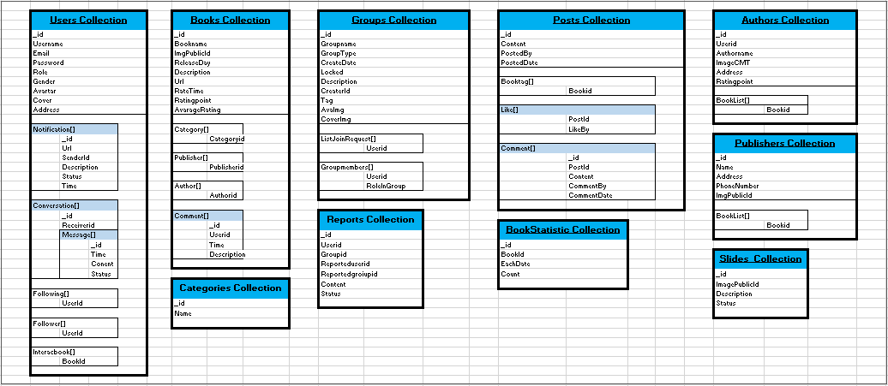

**Figure 2‑2:** Table Diagram

### Users Collection

|  |  |  |  |  |
| --- | --- | --- | --- | --- |
| Filed Name | | | Type | Description |
| _id | | | ObjectId | Mongodb objectid  Unique for each document |
| UserName | | | String | User’s name |
| Email | | | String | User’s Email |
| EmailConfirmed | | | Boolean | Status of registration confirmation via email |
| PasswordHash | | | String | Password encrypt by SHA 256 |
| Role | | | String | User’s role |
| Gender | | | String | User’s gender |
| Avatar | | | String | Publicid of user’s avatar in cloudinary |
| Cover | | | String | Publicid of user’s cover in cloudinary |
| DOB | | | DateTime | User’s date of birth |
| Address | | | String | User’s address |
| SSNImgId | | | String | User’s SSN image publicid in cloudinary |
| Interacbook |  | | Array[String] | List of book’s id that user interac with it |
| BookId | | ObjectId | Book’s id |
| Follower |  | | Array[String] | List other user’s id that follow user’s account |
| UserId | | ObjectId | User’s id |
| Following |  | | Array[String] | List other user’s id that user followed |
| UserId | | ObjectId | User’s id |
| Notification |  | | BsonArray | List user’s notification |
|  | _id | | ObjectId | User’s id |
| Url | | String | Notification’s link |
| SenderId | | ObjectId | Sender’s id |
| Conversation |  | | BsonArray | List user’s conversation |
|  | _id | | ObjectId | Mongodb objectid |
| ReceiverId | | ObjetcId | Mongodb objectid |
| Message |  | BsonArray | List message of conversation |
|  | _id | ObjectId |  |
| Time | DateTime | Time send message |
| Content | String | Message’s content |
| Status | Boolean | Message’s status(seen, unseen) |

Table ‑: Users Collection

### Posts Collection

|  |  |  |  |
| --- | --- | --- | --- |
| Field Name | | Type | Description |
| _id | | ObjectId | Mongodb objectid  Unique for each document |
| Content | | String | User’s post content |
| PostedBy | | String | User’s id |
| PostedDate | | DateTime | Time of user’s post |
| BookTag |  | Array[String] | List of book taged in user’s posst |
| BookId | ObjectId | Book’s id |
| Like |  | BsonArray | List like of user’s post |
|  | PostId | String | User’s Post’s id |
| LikeBy | String | User’s id |
| Comment |  | BsonArray | List comment of user’s post |
|  | _id | ObjectId | Mongodb objectid  Unique for each document |
| PostId | String | User’s Post’s id |
| Content | String | Content of User’s comment |
| CommentedBy | String | User’s id |
| CommentedDate | DateTime | Comment’s date |

Table ‑: Posts Collection

### Books Collection

|  |  |  |  |
| --- | --- | --- | --- |
| Field Name | | Type | Description |
| _id | | ObjectId | Mongodb objectid  Unique for each document |
| BookName | | String | Book’s name |
| ImgPublicId | | String | Book’s image publicid in cloudinary |
| ReleaseDay | | DateTime | Date of book release |
| Url | | String | Link detail of book |
| Description | | String | Content of book |
| RateTime | | Int | Sum rating point of each rate |
| RatingPoint | | Int | Sum rating time |
| AvarageRating | | Double | RatingPoint/RateTime |
| Category |  | Array[String] | List category’s id of book |
| CategoryId | ObjectId | Category’s id |
| Publisher |  | Array[String] | List publisher’s id of book |
| PublisherId | ObjectId | Publisher’s id |
| Author |  | Array[String] | List author’s id of book |
| AuthorId | ObjectId | Author’s id |
| Comment |  | BsonArray | List comment of book |
|  | _id | ObjectId | Mongodb objectid |
| UserId | ObjectId | Mongodb objectid |
| Time | DateTime | Date time of comment |
| Description | String | Content of comment |

Table ‑: Books Collection

### Authors Collection

|  |  |  |  |
| --- | --- | --- | --- |
| Field Name | | Type | Description |
| _id | | ObjectId | Mongodb objectid  Unique for each document |
| UserId | | ObjectId | User’s id |
| AuthorName | | String | Name of Author |
| RatingPoint | | Double | Author’s rating point |
| BookList |  | Array[String] | List Book of Author |
| BookId | ObjectId | Book’s id |

Table ‑: Authors Collection

### Publishers Collection

|  |  |  |
| --- | --- | --- |
| Field Name | Type | Description |
| _id | ObjectId | Mongodb objectid  Unique for each document |
| Name | String | Publisher’s name |
| PhoneNumber | String | Publisher’s phone number |
| ImagePublicId | String | Publisher’s image publicid in cloudinary |
| Address | String | Publisher’s address |

Table ‑: Publishers Collection

### Reports Collection

|  |  |  |
| --- | --- | --- |
| Field Name | Type | Description |
| _id | ObjectId | Mongodb objectid  Unique for each document |
| UserId | ObjectId | User’s id |
| GroupId | ObjectId | Group’s id |
| Reporteduserid | ObjectId | Id of user reported |
| Reportedgroupid | ObjectId | Id of group reported |
| Content | String | Content of report |
| Status | Boolean |  |

Table ‑: Reports Collection

### Category Collection

|  |  |  |
| --- | --- | --- |
| Field Name | Type | Description |
| _id | ObjectId | Mongodb objectid  Unique for each document |
| Name | String | Category’s name |

Table ‑: Category Collection

### Groups Collection

|  |  |  |  |
| --- | --- | --- | --- |
| Field Name | | Type | Description |
| _id | | ObjectId | Mongodb objectid  Unique for each document |
| GroupName | | String | Book’s name |
| Locked | | Boolean | Status of group(lock or not) |
| GroupType | | String | Group’s type |
| CreateDate | | DateTime | Date time group created |
| Tag | | String | Group’s tag(author’s name or book’s name) |
| CreaterId | | String | Id of user that created group |
| Description | | String | Content of group |
| CoverImg | | String | Group cover’s image public id in cloudinary |
| AvaImg | | String | Group avatar’s image public id in cloudinary |
| ListJoinRequest |  | Array[String] | List of users request to join group |
| UserId | ObjectId | User’s id |
| GroupMembers |  | Array[String] | List of group members |
| UserId | ObjectId | User’s id |
| RoleInGroup | String | Group member role name |

Table ‑: Groups Collection

### Slides Collection

|  |  |  |
| --- | --- | --- |
| Field Name | Type | Description |
| _id | ObjectId | Mongodb objectid  Unique for each document |
| ImagePublicId | String | Slide’s image publicid in cloudinary |
| Description | String | Content of slide |
| Status | Boolean | Slide’s status (on or off) |

Table ‑: Slides Collection

### BookStatistic Collection

|  |  |  |
| --- | --- | --- |
| Field Name | Type | Description |
| _id | ObjectId | Mongodb objectid  Unique for each document |
| BookId | String | Book’s id |
| EachDate | DateTime |  |
| Count | int |  |

Table ‑: BookStatistic Collection